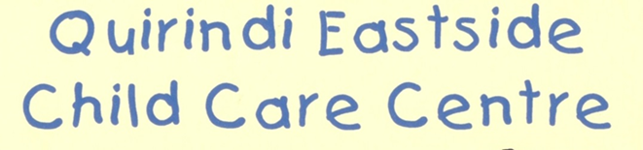
0-3 YEAR SUPPLEMENT

Child's Name......................................................Date of Birth………………………………………………
This form will be left with the staff in your child’s room for ease of reference and to assist casual staff and other staff to be familiar with your child’s routines.
Child's Daily Routine.
On the following lines, please give a brief description of your child's daily routine, for the time that they will attend the centre - between 8am and 6pm. (Duration and times of sleep times, meal times, etc.):
................................................................................................................................................................................................................................................................................................................................................................................................................................................................................................................................................................................................................................................................................................................................................................................................................................................................................................................................................................................................................................................................................................................................................................................................................................................................................................................................................................................................................................................................................................................................................................................................................................................................................................................................................................................................................................................................................................................................................................................................................................................................................................................................................................................................................................................................................................................................................................................................................................................................................................
Does your child have a security object for comfort or at rest time: Yes / No
Specify:…………………………………………………………………………………………………………………………………..
Preferred sleeping position:……………………………………………………………………………………………………
Bottles and feeding Is Your child
Breast fed: Yes / No
Formula fed: YES / NO Name of formula used...........….......................................................
Other please specify.........................................................................................................................
How often will your child require a feed (breast/bottle)? .....................................................................
Approximately what times of the day? ................................................................................................
Amount:.........................................................................................................................................
Preferred temperature of bottles WARM / COLD

Allergies
Does your child suffer from any allergies? (food, plant, insect, grass, etc.)
.................................................................................................................................................................................................................................................................................................................................................................................................................................................................
General
Is there anything your child is especially wary of? (loud noises etc.)
………………………………………………………………………………………………………………………………………………………………………………………………………………………………………………………………………………………………………………………………………………………………………………………………………………………………………………

I give permission for the staff at Quirindi Eastside Child Care Centre to apply the following to my child if needed:
Nappy change lotion, cream or powder Yes / No
Insect repellent Yes / No
Sunscreen lotion Yes / No

Any further comments or things you feel we should know about your child?
Is there any further information which you feel may assist us in providing the best service to you and your child (eg religious/cultural beliefs or practices, family situation, recent significant events, special likes/dislikes, personality etc.).
........................................................................................................................................................................................................................................................................................................................................................................................................................
........................................................................................................................................................................................................................................................................................................................................................................................................................................................................................................................................................................................................................................................................................................................................................................................................................................................................................................................................................................................................................................................................................................................................................................................................................................................................

Thank you for taking the time to complete this form.

Parent's Signature.................................................
Date form was completed....................................

Parents are asked to update and add to this form as your child’s routine and information changes

